**BTEC Extended Certificate**

In Creative Digital Media Production

**UNIT 13: Graphic Design for Digital Media**

**UNIT 16: Digital Art for a Media Product**

Researching, designing and developing graphics for a digital media product

**Learner’s Name: Aaron Coleman**

**Learner declaration**

I certify that the evidence submitted for this assignment is my own. I have clearly referenced any sources used in the work. I understand that false declaration is a form of malpractice.

**Learner signature:acoleman313@howcollege.ac.uk**

**Date: 21/9/2015**

# Researching Existing Graphics

# Graphic One

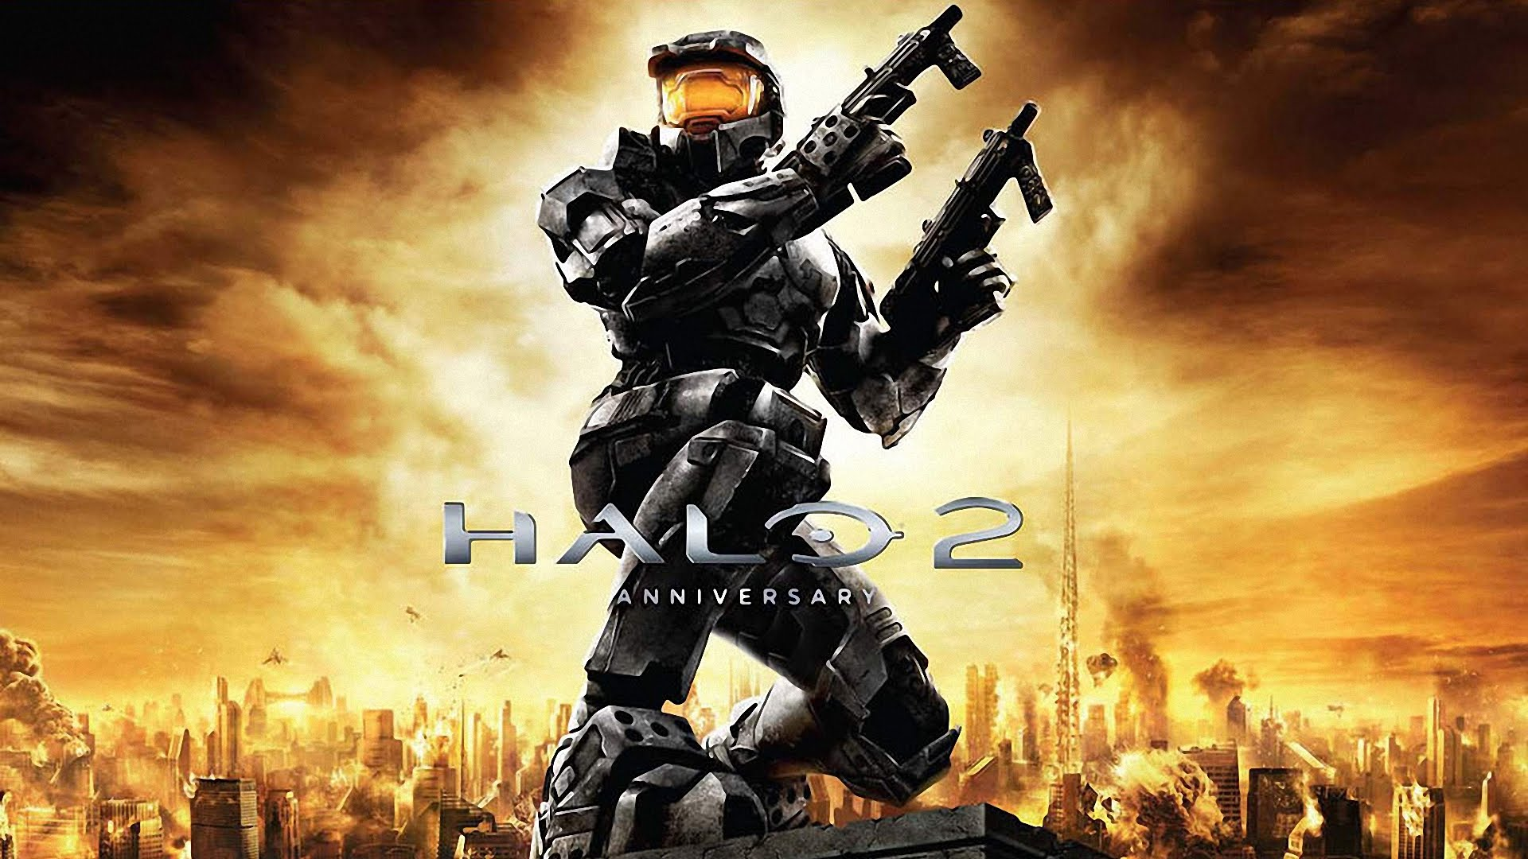

## Description

This graphic is a poster for the anniversary soundtrack of the game halo 2. It is used to remind people of this game, so more people would get nostalgic and remember this game to help market it or one of the later versions and advertise its soundtrack out to people.

## Style

The style this graphic is a futuristic space style, you can see this by the background where u can see little spaceship type objects and also by the characters clothes as they are obviously from the future.

## Genre

The genre of this graphic is sci-fi first person shooter, you can see this by the whole image it has a futuristic feel to it and the characters weapon’s show that this game is a first person shooter.

## Technical Qualities

The colours of this graphic blend nicely together with the main characters appearance, it gives a rugged far in the future feel. You can tell that this graphic has been photoshoped, In the way they got the character in there and just blended it in, you can see this by the pillar he is standing on there’s a few notches that are not cut out perfectly.

## Communication of Meaning

The mood of this is quite dark and destructive, this is because of both the colour of the background and what’s actually in the background, buildings on fire and rubble, giving a very dark and dangerous game. Also the name of it, Halo, is something that symbolises angels and power which is also something light and heavenly which clashes with the main picture.

## How effective is the design?

The design works well with the whole picture which is thought though, it goes together, but unfortunately it also contradicts itself, the name Halo symbolises angels while the image shows something much more destructive.

# Graphic Two

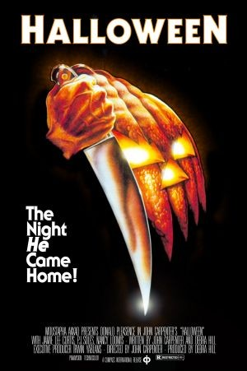

## Description

This graphic is a poster for a horror movie called Halloween. It is used to get the attention of people, and draw them in to paying to see it or buying it.

## Style

This graphic has a dark and spooky style to it, with a pitch black background and a single picture, with one line of writing gives it a dark and final note.

## Genre

This movie is definitely a horror movie you can see this by the pumpkin which is usually done at Halloween same with the title which is just that it’s supposed to look scary with a sharp gleaming knife with a creepy looking pumpkin and around it nothing else Just black.

## Technical Qualities

The image is layer out in a scary dark way with a pumpkin that looks like it has an arm wielding a knife black is used to make a feeling of the unknown and fear. You can tell Photoshop was used as there’s a small rectangle bit on the hand at the bottom where it’s been just missed when they cut it out.

## Communication of Meaning

The mood is dark and scary with dark colours the pumpkin symbolises Halloween and the knife violence and death so this movie will be violent is makes the viewer want to see it just to scare themselves.

## How effective is the design?

This design works perfectly for its purpose it shows that it is a scary movie and sort of what’s it about without giving too much away.

# Graphic Three

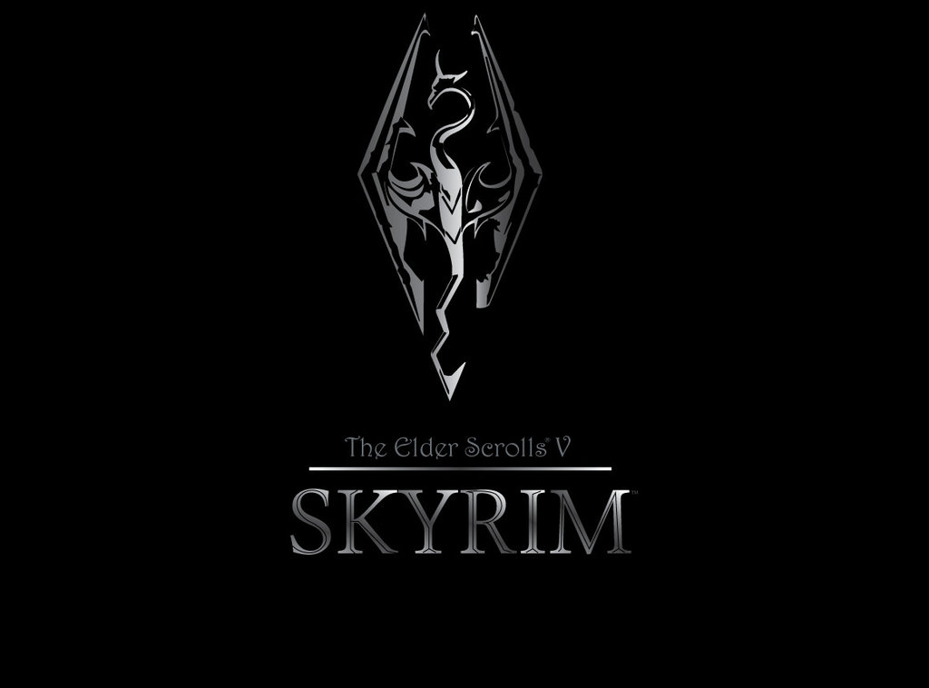

## Description

This graphic is a poster for the game skyrim it is used to attract people to buy the game.

## Style

The style of this poster is more medieval and elegant with the silver dragon shape pattern in a black background representing the unknown.

## Genre

It’s a medieval RPG game set in a fantasy world.

## Technical Qualities

The layout is simple but effective with just 2 colours used silver and black with one picture and the title to build up suspense but you can tell it has been photoshoped as one part of the axe has been completely chopped off this could be on purpose but I’ve seen some with the piece and some without.

## Communication of Meaning

It’s a dark mood with all the colours being darker black is used in the background this could hint at the medieval sign such as the dark ages the silver is used to represent metal such as a sword the main logo is a dragon shaped axe this could symbolise that you would kill dragons.

## How effective is the design?

Its effective in it draws you in just to see what it’s about I would be happy as long as the main picture is complete as it’s a good design and has a lot of potential.

# **Design Brief**

The purpose of my designs is to create a company and a product.

My company values good films at good prices that are at the very high standard people deserve

My product is a film.

Genre, horror

Target audience 16+ horrors both male and female 20-40

Sketches

# Logo Design 1

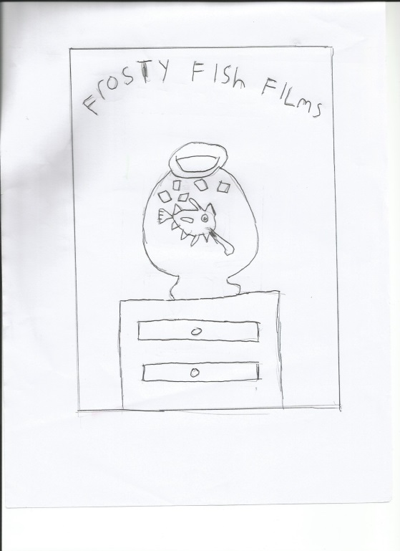

I like this design as it sounded like a nice name and I just loved the image

# Logo Design 2

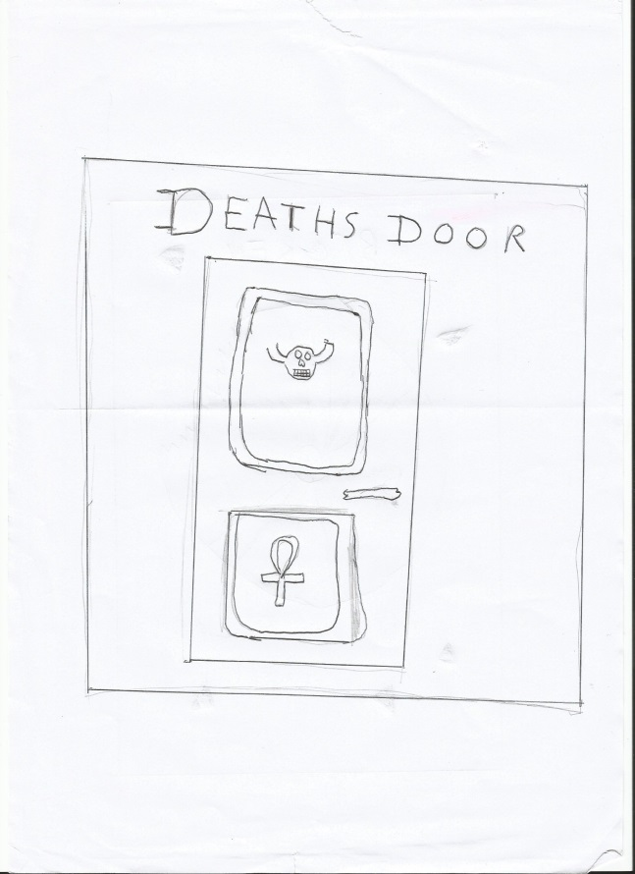

I got inspired by this design because when I thought of horror I thought of death then the saying knocking on deaths door came to mind so I made deaths door

# Logo Design 3

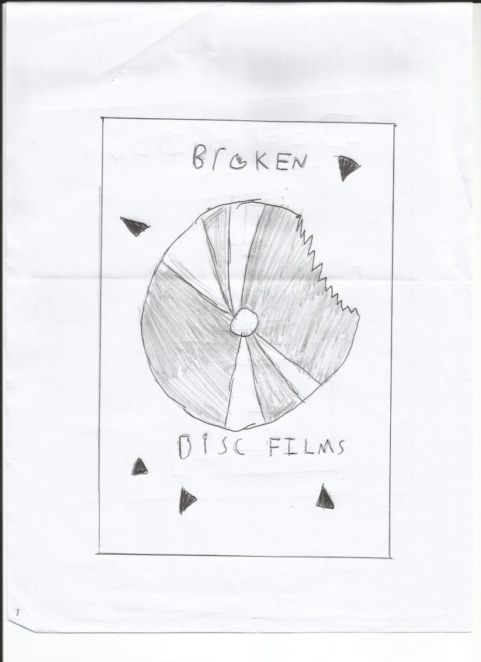

I chose this idea because it was honestly the best well thought out without being stupidly complicated.

# Product Image Design 1

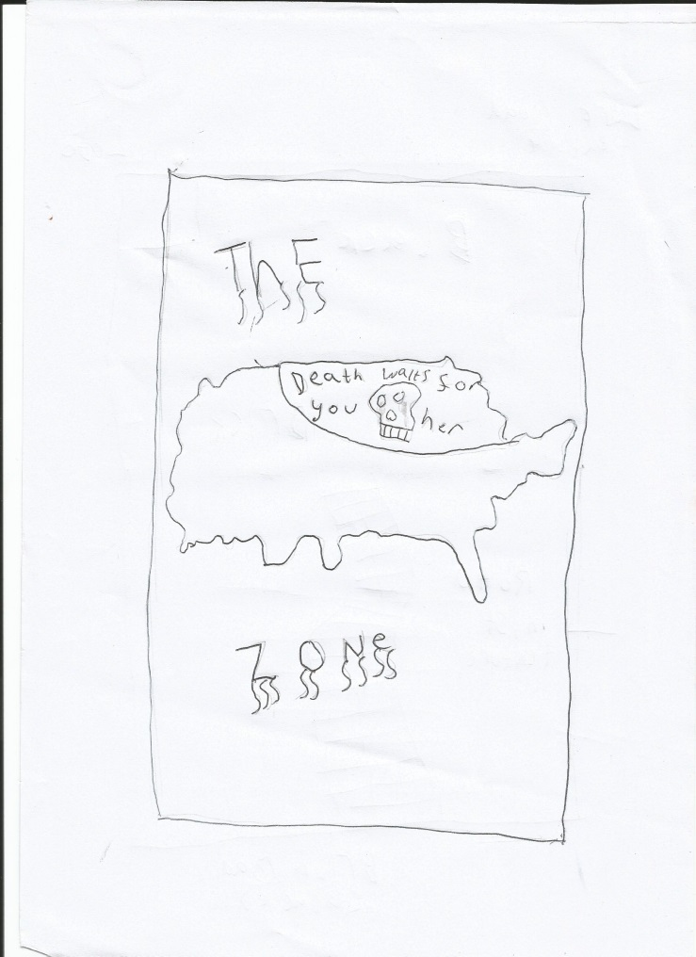

I got this idea from a mix of things a game I saw called the last of us which had a great idea of zones split up after the apocalypse so I decided to morph that idea into this cover.

# Product Image Design 2

# Product Image Design 3

# 

I thought of this when I thought of sort of an action horror so I did a drawing used a random name generator picked the best one searched to make sure it wasn’t taken and wrote the name.

I thought of this idea when searching the web for graphics and I saw the wizard of oz. and as I was doing a horror why not morph it into a sort of evil wizard of oz. type world the creation was this**.**

# 

# Development Process

First make 3 circles first a large black one

Second a small white then a smaller black

And then the smallest white fit these

Together to have a disk then use the

Polygon toll to highlight parallel triangles

And cut them out. Then using the polygon

Break the disc up into shards and arrange

It in the far left then selects the font fixedsys

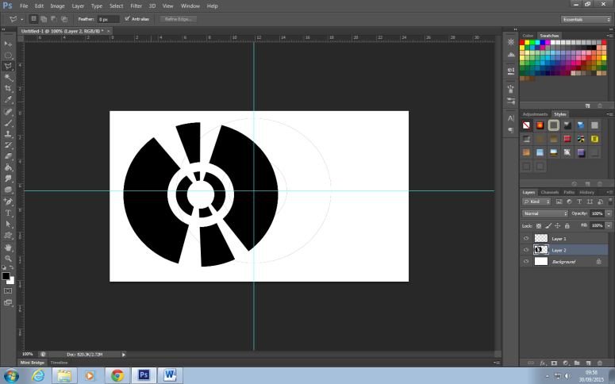And write the title then using the rectangle

Tool create a rectangle around the writing and disc not too close to the

Edge and colour the background.

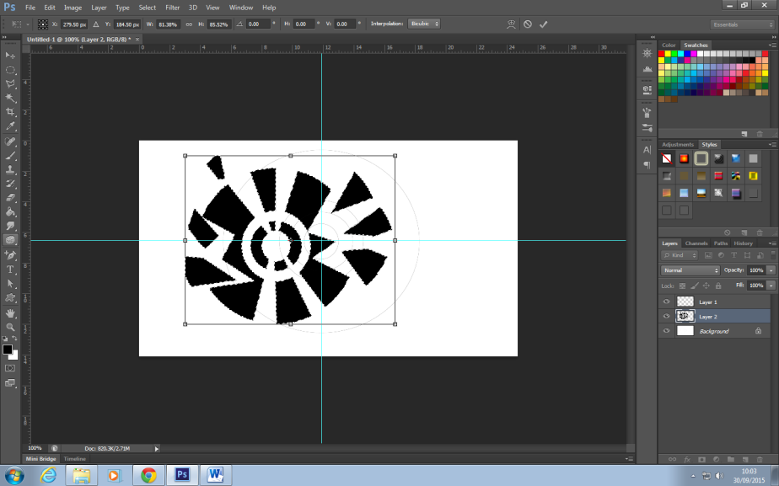

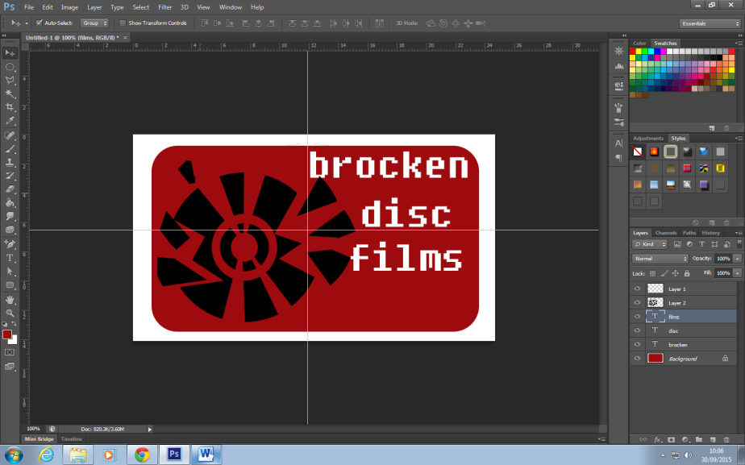

Completed Images

Company Logo

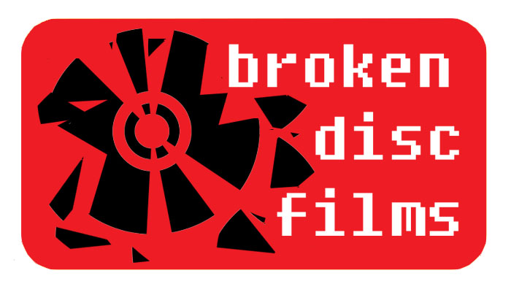

Product Image

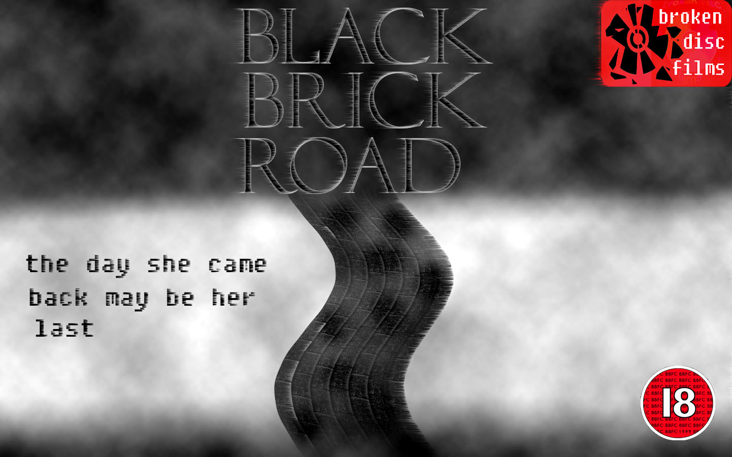

# References

* www.youtube.com - Halo 2 Anniversary Soundtrack - Full Album (iTunes OST)
* Halloween picture - solopress.com
* Skyrim logo - freman414.deviantart.com